“I can do everything through Him who gives me strength.” -- Philippians 4:13

- Please show all your work! No partial credit will be given for incorrect answers with no work shown. Please draw a box around your final answer.
- Calculators are permitted, but no notes, text, laptops, or PDAs. Cell phones should be muted and left in your pocket or bag. Electronic dictionaries are okay.

Simplify (exact answers):
- 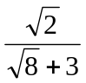 [2]
3 sqrt(2) – 4
- 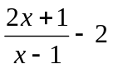 [2]
3 / (x-1)
- (9² x⁻³) / (3⁵ x⁻⁴) [2]
x/3
- 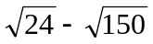 [2]
-3 sqrt(6)
Factor:
- z³ – 14z [3]
z (z – sqrt(14)) (z + sqrt(14))
- x² + 12x – 28 [2]
(x – 2) (x + 14)
- m² – 4m – 6 [4]
(m – (2 + sqrt(10)) (m – (2 – sqrt(10)))
(quadratic formula)
Solve:
- z² + 3z = 18 [3]
-6 or +3
- | (x/2) – 5 | < 9 [3]
-8 < x < 28
- 2x² – x – 3 = 0 [4]
3/2 or -1
- s³ – 6s² + 12s – 8 = 0 [3]
2

Word Problems
- Write an expression for the general term t_{n} of each sequence given below.
  - -15, -8, -1, 6, 13, … [2]
t_{n} = -15 + 7(n-1) = -22 + 7n
  - 4/3, 2, 3, 9/2, 27/4, … [2]
t_{n} = (4/3)(3/2)^{n-1} = (8/9)(3/2)^{n}
  - 2, ½, 2/9, 1/8, 2/25, 1/18, … [2]
t_{n} = 2n⁻²
- Find the centre and radius of the circle x² + 4x + y² – 16y = 5. [4]
Centre (-2, 8), radius sqrt(73)
- You have $500 cash to spend as you please. Your mother advises you to invest it in your RRSP, earning interest at 14% p.a. compounded monthly. Instead, you buy a brand new portable MP3 player for $500. The MP3 player depreciates rapidly, losing 45% of its value each year.
  - After two years, you decide to sell the MP3 player. What is the depreciated value of the MP3 player? [2]
$151.25
  - If you had listened to your mother, how much would your $500 have grown to in those two years in the RRSP? [4]
~$660.49
  - What was the real total cost of ownership of the MP3 player for those two years? (i.e., how much you sold it for versus how much you would have made if you listened to your mother.) [1]
~$509.24
- A rocket ship fires its thrusters steadily. After t seconds, its distance from a rendezvous point in metres is given by
–4t² + 24t + 36
  - When will the rocket reach the rendezvous point (zero distance)? [3]
After ~7.243 seconds
  - What is the maximum distance the rocket reaches from the rendezvous point? [4]
72 metres
- Find the equation of the line equidistant to the two points (-1,2) and (3,0). [4]
y = 2x – 1
- You have three debts that you wish to consolidate: $800 due 3 months ago, $200 due in one month, and $400 due 8 months from now. How much do you need to repay all three debts now? Assume interest is 18% p.a. compounded monthly. [5]
~$1388.67
- Consider the series 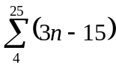.
  - What is the first term of the series? [1]
-3
  - What is the last term of the series? [2]
60
  - What is the sum of the series? [3]
627
- Give an exact answer for the sum of the series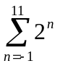. [4]
4095.5
- b varies directly with (a – 3), and c varies inversely with b². When a is 1, c is 3. What is the value of c when a is -2? [4]
12/25
- How long will it take a population of bacteria to grow from 150 to 4,000,000, at a continuous growth rate of 22% per minute? [4]
~46.32 min
- Start-up costs for your new bookstore are $4500. Your average costs per sale are $10, and your average revenue per sale is $12.
  - Assuming a linear cost function, what is your cost function? [1]
C(x) = 4500 + 10x
  - How many sales do you need to make to break even? [3]
2250
- A fighter jet travels along the straight line y = -3x + 2 (units are given in km). Its target is at coordinates (4,2). At what points is the jet exactly 4km from its target? Give exact answers. [6]
(0,2) and (4/5, -2/5)
- To buy your house, you obtain a $160,000 mortgage. The loan has 30-year amortization, i.e., you would pay it off in 30 years if you made only the regular payments. The interest rate is 8% p.a., compounded monthly. Equal monthly payments are made at the end of each month. How much is each monthly payment? [8]
~$1174.02

- A manufacturing plant produces two models of cell phones, the A400 and the B15. To produce one model A400 requires 30 minutes of assembly and 10 minutes of testing. To produce one model B15 requires 20 minutes of assembly and 15 minutes of testing. Each day, 200 worker-hours of assembly and 90 worker-hours of testing are available. The management wants the plant to be producing at least 240 model A400s each day.
  - Set up inequalities corresponding to the constraints on the number of each model of phone that the manufacturing plant can produce each day. [4]
30a + 20b <= 12000
10a + 15b <= 5400
a >= 240
b >= 0
  - Sketch a graph and shade the region corresponding to the allowable number of each model of phone that the plant can produce each day. [4]
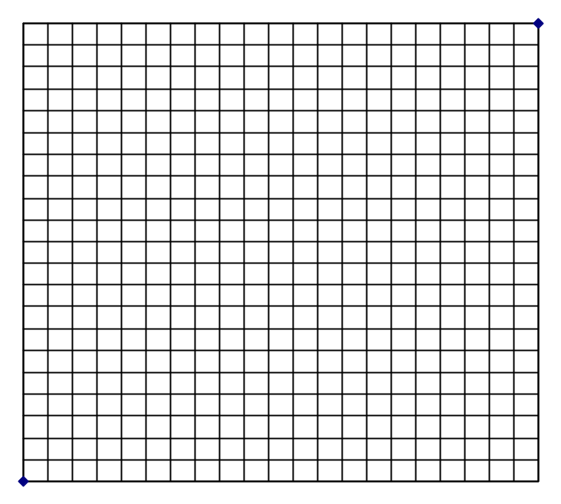
  - Assume that the company makes $17 profit from each A400 phone and $26 profit from each B15 phone. How many of each model of phone should the plant produce each day in order to maximize profit? What is that maximum profit? [3]
a=240, b=200, profit=$9,280

